# 1， svn 和 git的区别

svn : 必须要一个中央处理器，联网才能进行工作，局限性比较大； git则客服了相应的问题；

git 也需要按照自定义的方式来创建一个中央管理器，且是分布式的管理；

所有的代码只有一份拷贝，管理添加的文件和删除的文件，文件修改的部分；（只记录管理修改的部分）

# 2， 创建一个项目的流程：

先是管理代码员以自己的中间的服务器进行项目管理的厂库，即Remote Reposity;

开发人员即fork Remote Reposity， 放到自己的服务器中；

差异的文件，都是在git 或 gitignore来记录的;

初始化时需要提供账户和密码配置；每次提交都有一个ID;

# 3，TortoiseGit 的使用；Git Bash的安装；

# 4，分支的管理；branch

5, fetch 和 push 区别 ，clone 和fork区别， rebase的定义；

# 6，分支的改变，相对应的代码也会随着改变；

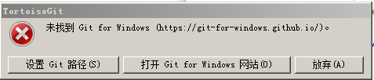

# 7, 对于Android Studio 的adb来调试代码时，

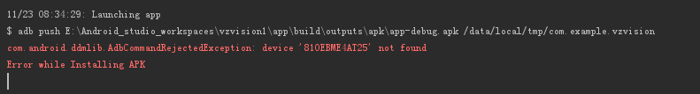

11/23 08:34:29: Launching app

$ adb push E:\Android_studio_workspaces\vzvision1\app\build\outputs\apk\app-debug.apk /data/local/tmp/com.example.vzvision

com.android.ddmlib.AdbCommandRejectedException: device '810EBME4AT25' not found

Error while Installing APK

安装APK文件出现了错误；

# 8，对于github的账户和密码：[13265539954@163.com](mailto:13265539954@163.com) 密码：{1qaz2wsx...}

# 9，对于adb的调试，需要和唐工进行联系来方便解决；

# 

10，SurfaceView <http://blog.csdn.net/jinzhuojun/article/details/44062175>

# 11, 使用mediaPlayer出现错误了，是自己的原因，必须要在onCreate()中设置callback

12, 解压文件出现错误；（在非解压盘才能解决）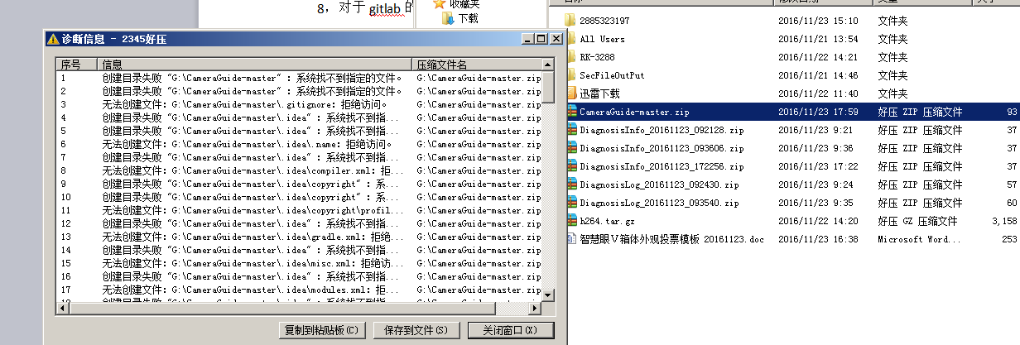

# // 有道云笔记

# 1, SurfaceView 的优点；

<http://www.jianshu.com/search?q=Android+SurfaceView&page=1&type=notes>

# 2，SurfaceView使用的编程模型；

实例一：画画；

关于Android UI方面的，<http://www.jianshu.com/p/fe812d3459b4>

注意，对于屏幕的尺寸的大小有点问题；而且还是循环的； VideoView 可以同时完成View的显示和视图的显示；

MediaPlayer + SurfaceView显示画面有问题；

1, 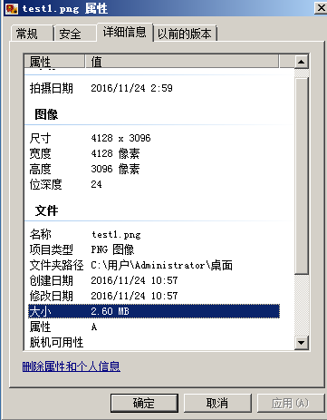

4128 * 3096 位深度为24, 大小为2.6MB，(??)

# 2, NDK编码出现的问题；

|  |
| --- |
| Information:Gradle tasks [:app:clean, :app:generateDebugSources, :app:generateDebugAndroidTestSources, :app:mockableAndroidJar, :app:prepareDebugUnitTestDependencies, :app:assembleDebug]  Error:Execution failed for task ':app:compileDebugNdk'.  > Error: Your project contains C++ files but it is not using a supported native build system.  Consider using CMake or ndk-build integration with the stable Android Gradle plugin:  https://developer.android.com/studio/projects/add-native-code.html  or use the experimental plugin:  http://tools.android.com/tech-docs/new-build-system/gradle-experimental.  Information:BUILD FAILED  Information:Total time: 1.387 secs  Information:1 error  Information:0 warnings  Information:See complete output in console  (需要ndk的部分来编码支持c++文件，但是对于自己本地的播放器，是没有用到的) |

# 3, 对于远程的放开策略来构建良好的调试环境

针对于Android studio 而言，涉及到的有；

1，USB OTG adb 的调试；adb shell 命令行调试；

2，对于 adb 设备的连接；点击运行时，不能显示相应的 Android 设备；

3，对于 使用ADB Manager 来下载 System Image 和 Develop Tools 工具，需要连接上网，进行在线的下载；

4，对于Android Studio 支持有较多的plugins 插件，也是需要在线下载；

5，对于 Android Studio 支持较多的第三方库，也是需要在线进行下载；





# 4, 安装停车场客户端信息：



# 5, 播放器的error

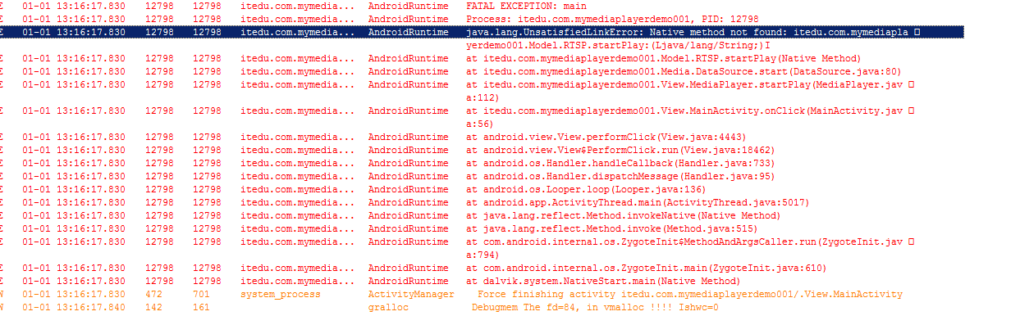

出现的问题，即包的名字，需要和类一样；即涉及到jni ndk的实现；

# 6, 播放器的目录结构

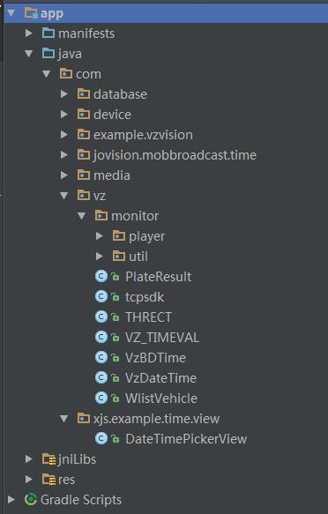

Com.example.vzvision,

# 7, 运行分布式停车管理系统；

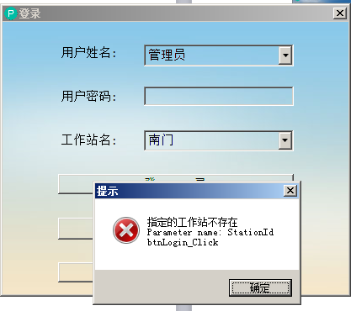，都是出现这个问题，指定的工作站不存在；

# 8，对于自己将 OpenGl 单独的控件来显示视频数据；

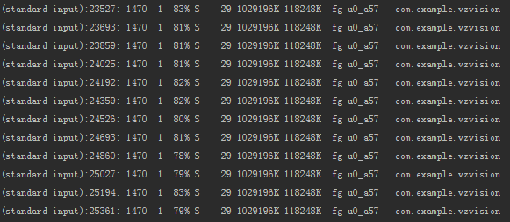

Cpu使用率达到了80%, 解码数据即为2个720P;

RK3288 使用案例的解码能力大致为：

同时进行2路硬编码和5路硬解码情况下，720P硬编解码可达26~30帧/秒，而1080p硬编解码可达13~15帧/秒。

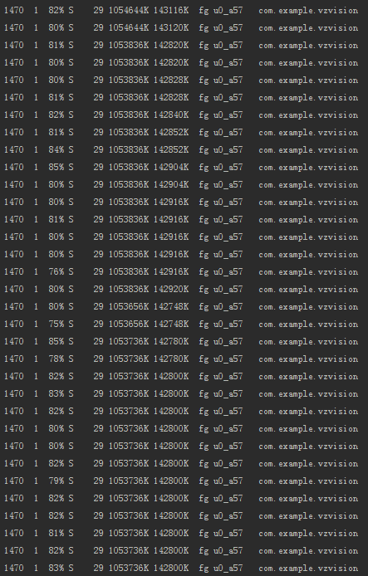

9，发现跑一段时间的vzvision之后，cpu会变成97%;

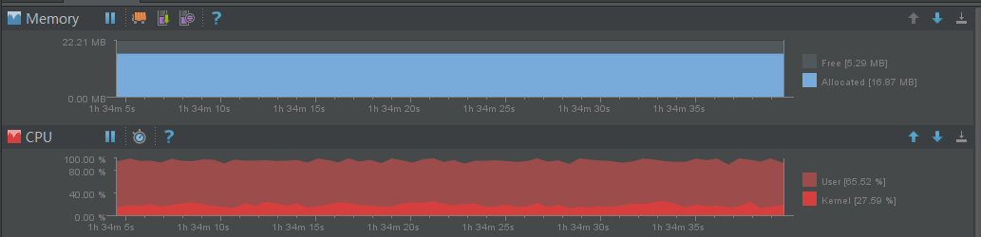

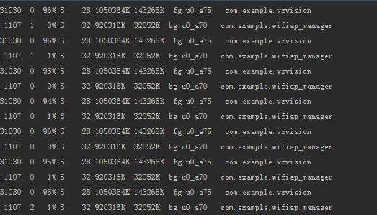

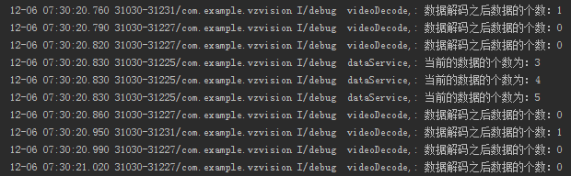

表示获取解码的数据个数为5，但是解码之后的数据为0，即表示因为一定的原因，造成了解码能力达不到了；

# 9, 使用Androidvlc来播放视频，cpu和内存都不是很高，但是一段时间后出现了播放器主动关掉的情况；

12-07 09:12:46.161 14491-14669/com.compdigitec.libvlcandroidsample W/VLC: core video output: picture is too late to be displayed (missing 74 ms)

12-07 09:12:46.231 14491-14669/com.compdigitec.libvlcandroidsample D/VLC: core video output: picture might be displayed late (missing 9 ms)

可能是什么原因导致的??(不论哪种的播放器，都出现的不是很稳定，且涉及到JNI NDK的编码过程，所以这是自己以后一个方向)

# 10，加入休眠的处理后，一个视频解码的cpu为30%左右；

# 11，人脸识别apk的对比；

|  |  |  |
| --- | --- | --- |
|  | TaiSDK.dll库(Windows) | TesoFaceLib.jar(Android) |
| Sdk的初始化 | int face_init(); | TESO_init(context, multiThreadSupport[]) |
| Sdk去初始化 | int face_exit() | TESO_Deinit(context, currentThread) |
| 获取特征参数 | 从图像串获取人脸特征  int face_get_feature();  从图像文件获取人脸特征  int face_get_feature_from_image()  从内存图像获取人脸特征  int face_get_feature_from_memory() | 从Bitmap来获取人脸特征  String TESO_GetFaceFeature(); |
| 获取人脸坐标 | 获取图像中人脸的坐标  int face_get_pos()  获取图像帧中人脸的坐标  int face_get_pos_from_frame() | 无 |
| 对比特征参数 | 两个人脸特征进行对比  int face_comp_feature() | int face_comp_feature(); |
| 是否存在人脸 | int face_exist() | 无 |

12, github的网址；是?

13

|  |  |
| --- | --- |
| D:\Android_studio_workspaces\Parking-devlope\parking\build\intermediates\res\merged\debug\values\values.xml  Error:(66) Error retrieving parent for item: No resource found that matches the given name 'Theme.AppCompat.Light'.  D:\Android_studio_workspaces\Parking-devlope\parking\build\intermediates\res\merged\debug\values-v11\values-v11.xml  Error:(3) Error retrieving parent for item: No resource found that matches the given name 'Theme.AppCompat.Light'.  D:\Android_studio_workspaces\Parking-devlope\parking\build\intermediates\res\merged\debug\values-v14\values-v14.xml  Error:(3) Error retrieving parent for item: No resource found that matches the given name 'Theme.AppCompat.Light.DarkActionBar'.  Error:Execution failed for task ':parking:processDebugResources'.  > com.android.ide.common.process.ProcessException: org.gradle.process.internal.ExecException: Process 'command 'D:\Android_SDK\Android\sdk\build-tools\25.0.1\aapt.exe'' finished with non-zero exit value 1 |  |

14, 执行抓图的时候，出现了

|  |
| --- |
| 12-15 16:40:25.437 24717-24783/? E/AndroidRuntime: FATAL EXCEPTION: Thread-2239  Process: com.znykt.zhpark, PID: 24717  java.lang.UnsatisfiedLinkError: com.android.tools.fd.runtime.IncrementalClassLoader$DelegateClassLoader[DexPathList[[dex file "/data/data/com.znykt.zhpark/files/instant-run/dex/slice-universal-image-loader-1.9.2-SNAPSHOT-with-sources_3ed07382f59a0349dbd70a16c5ffec28a0ace1fa-classes.dex", dex file "/data/data/com.znykt.zhpark/files/instant-run/dex/slice-support-annotations-22.2.1_9e1916f3be4d81bf6465a0d18ce56900c74715ca-classes.dex", dex file "/data/data/com.znykt.zhpark/files/instant-run/dex/slice-slice_9-classes.dex", dex file "/data/data/com.znykt.zhpark/files/instant-run/dex/slice-slice_8-classes.dex", dex file "/data/data/com.znykt.zhpark/files/instant-run/dex/slice-slice_7-classes.dex", dex file "/data/data/com.znykt.zhpark/files/instant-run/dex/slice-slice_6-classes.dex", dex file "/data/data/com.znykt.zhpark/files/instant-run/dex/slice-slice_5-classes.dex", dex file "/data/data/com.znykt.zhpark/files/instant-run/dex/slice-slice_4-classes.dex", dex file "/data/data/com.znykt.zhpark/files/instant-run/dex/slice-slice_3-classes.dex", dex file "/data/data/com.znykt.zhpark/files/instant-run/dex/slice-slice_2-classes.dex", dex file "/data/data/com.znykt.zhpark/files/instant-run/dex/slice-slice_1-classes.dex", dex file "/data/data/com.znykt.zhpark/files/instant-run/dex/slice-slice_0-classes.dex", dex file "/data/data/com.znykt.zhpark/files/instant-run/dex/slice-open_sdk_r4547_257da8c5b8c00d03b9e487a456d8d1f11b3b14f6-classes.dex", dex file "/data/data/com.znykt.zhpark/files/instant-run/dex/slice-okhttp-2.3.0_cd0e1b6b949303832012e8606cb1c92ba93fdeca-classes.dex", dex file "/data/data/com.znykt.zhpark/files/instant-run/dex/slice-libammsdk_e68f5e1891bfb8066093e09a064bde4a7a712ed4-classes.dex", dex file "/data/data/com.znykt.zhpark/files/instant-run/dex/slice-json_simple-1.1_395a03bc093637b71a671a4e73981a9a8e023b88-classes.dex", dex file "/data/data/com.znykt.zhpark/files/instant-run/dex/slice-internal_impl-22.2.1_96bb4149f76f3fc12a45a1559908da83a30518b3-classes.dex", dex file "/data/data/com.znykt.zhpark/files/instant-run/dex/slice-gson-2.2.4_4bdf16c588ee034599c4d23163c8cca82363c4cb-classes.dex", dex file "/data/data/com.znykt.zhpark/files/instant-run/dex/slice-com.android.support-support-v4-22.2.1_ca4ae97d7a6af88979452f4104d0c3d5f2ffe813-classes.dex", dex file "/data/data/com.znykt.zhpark/files/instant-run/dex/slice-android-async-http-1.4.6_a0f2e86fe796450b419dfecfc6b2ee73a39ef3a9-classes.dex", dex file "/data/data/com.znykt.zhpark/files/instant-run/dex/slice-GetuiSDK2.9.3.0_480c359c5c9859788cd2e35feaed262b1f89f6c5-classes.dex"],nativeLibraryDirectories=[/data/app/com.znykt.zhpark-1/lib/arm64, /vendor/lib64, /system/lib64, /vendor/lib64, /system/lib64]]] couldn't find "libzbar.so"  at java.lang.Runtime.loadLibrary(Runtime.java:366)  at java.lang.System.loadLibrary(System.java:988)  at com.zbar.lib.ZbarManager.<clinit>(ZbarManager.java:15)  at com.zbar.lib.DecodeHandler.decode(DecodeHandler.java:63)  at com.zbar.lib.DecodeHandler.handleMessage(DecodeHandler.java:42)  at android.os.Handler.dispatchMessage(Handler.java:111)  at android.os.Looper.loop(Looper.java:194)  at com.zbar.lib.DecodeThread.run(DecodeThread.java:50) |

15， 从摄像机获取的图片；

/storage/emulated/0/Qrcode/Qrcode.jpg

16，java.lang.UnsatisfiedLinkError: com.android.tools.fd.runtime.IncrementalClassLoader$DelegateClassLoader[DexPathList[[dex file "/data/data/com.znykt.zhpark/files/instant-run/dex/slice-universal-image-loader-1.9.2-SNAPSHOT-with-sources_3ed07382f59a0349dbd70a16c5ffec28a0ace1fa-classes.dex", dex file "/data/data/com.znykt.zhpark/files/instant-run/dex/slice-tesofacelib_f46ca8b720eda72e704365fb94850aa30c8c2be9-classes.dex", dex file "/data/data/com.znykt.zhpark/files/instant-run/dex/slice-support-annotations-22.2.1_9e1916f3be4d81bf6465a0d18ce56900c74715ca-classes.dex", dex file "/data/data/com.znykt.zhpark/files/instant-run/dex/slice-slice_9-classes.dex", dex file "/data/data/com.znykt.zhpark/files/instant-run/dex/slice-slice_8-classes.dex", dex file "/data/data/com.znykt.zhpark/files/instant-run/dex/slice-slice_7-classes.dex", dex file "/data/data/com.znykt.zhpark/files/instant-run/dex/slice-slice_6-classes.dex", dex file "/data/data/com.znykt.zhpark/files/instant-run/dex/slice-slice_5-classes.dex", dex file "/data/data/com.znykt.zhpark/files/instant-run/dex/slice-slice_4-classes.dex", dex file "/data/data/com.znykt.zhpark/files/instant-run/dex/slice-slice_3-classes.dex", dex file "/data/data/com.znykt.zhpark/files/instant-run/dex/slice-slice_2-classes.dex", dex file "/data/data/com.znykt.zhpark/files/instant-run/dex/slice-slice_1-classes.dex", dex file "/data/data/com.znykt.zhpark/files/instant-run/dex/slice-slice_0-classes.dex", dex file "/data/data/com.znykt.zhpark/files/instant-run/dex/slice-open_sdk_r4547_257da8c5b8c00d03b9e487a456d8d1f11b3b14f6-classes.dex", dex file "/data/data/com.znykt.zhpark/files/instant-run/dex/slice-okhttp-2.3.0_cd0e1b6b949303832012e8606cb1c92ba93fdeca-classes.dex", dex file "/data/data/com.znykt.zhpark/files/instant-run/dex/slice-libammsdk_e68f5e1891bfb8066093e09a064bde4a7a712ed4-classes.dex", dex file "/data/data/com.znykt.zhpark/files/instant-run/dex/slice-json_simple-1.1_395a03bc093637b71a671a4e73981a9a8e023b88-classes.dex", dex file "/data/data/com.znykt.zhpark/files/instant-run/dex/slice-internal_impl-22.2.1_96bb4149f76f3fc12a45a1559908da83a30518b3-classes.dex", dex file "/data/data/com.znykt.zhpark/files/instant-run/dex/slice-gson-2.2.4_4bdf16c588ee034599c4d23163c8cca82363c4cb-classes.dex", dex file "/data/data/com.znykt.zhpark/files/instant-run/dex/slice-com.android.support-support-v4-22.2.1_ca4ae97d7a6af88979452f4104d0c3d5f2ffe813-classes.dex", dex file "/data/data/com.znykt.zhpark/files/instant-run/dex/slice-bugly_crash_release__2.1_899643f871978ed5dd60524e0c6a88653ffcd9de-classes.dex", dex file "/data/data/com.znykt.zhpark/files/instant-run/dex/slice-android-async-http-1.4.6_a0f2e86fe796450b419dfecfc6b2ee73a39ef3a9-classes.dex", dex file "/data/data/com.znykt.zhpark/files/instant-run/dex/slice-GetuiSDK2.9.3.0_480c359c5c9859788cd2e35feaed262b1f89f6c5-classes.dex"],nativeLibraryDirectories=[/data/app/com.znykt.zhpark-2/lib/arm64, /vendor/lib64, /system/lib64, /vendor/lib64, /system/lib64]]] couldn't find "libSsNow.so"

(相应的库文件没有找到)

# 17, Framework

public class View implements Drawable.Callback, KeyEvent.Callback,

AccessibilityEventSource {}

public static interface Callback {

public void invalidateDrawable(Drawable who);

public void scheduleDrawable(Drawable who, Runnable what, long when);

public void unscheduleDrawable(Drawable who, Runnable what);

}

public interface Callback {

boolean onKeyDown(int keyCode, KeyEvent event);

boolean onKeyLongPress(int keyCode, KeyEvent event);

boolean onKeyMultiple(int keyCode, int count, KeyEvent event);

}

public interface AccessibilityEventSource {

public void sendAccessibilityEvent(int eventType);

public void sendAccessibilityEventUnchecked(AccessibilityEvent event);

}

On方法：

protected void onFocusChanged(boolean gainFocus, int direction, Rect previouslyFocusedRect);

public void onStartTemporaryDetach();

public void onFinishTemporaryDetach();

public void onWindowFocusChanged(boolean hasWindowFocus) ;

protected void onVisibilityChanged(View changedView, int visibility);

protected void onDisplayHint(int hint);

protected void onWindowVisibilityChanged(int visibility);

protected void onConfigurationChanged(Configuration newConfig);

public boolean onKeyPreIme(int keyCode, KeyEvent event);

public boolean onKeyShortcut(int keyCode, KeyEvent event);

public boolean onCheckIsTextEditor();

public InputConnection onCreateInputConnection(EditorInfo outAttrs);

public void createContextMenu(ContextMenu menu)

Public void onTrackballEvent(MotionEvent event);

# 18, Web缴费机

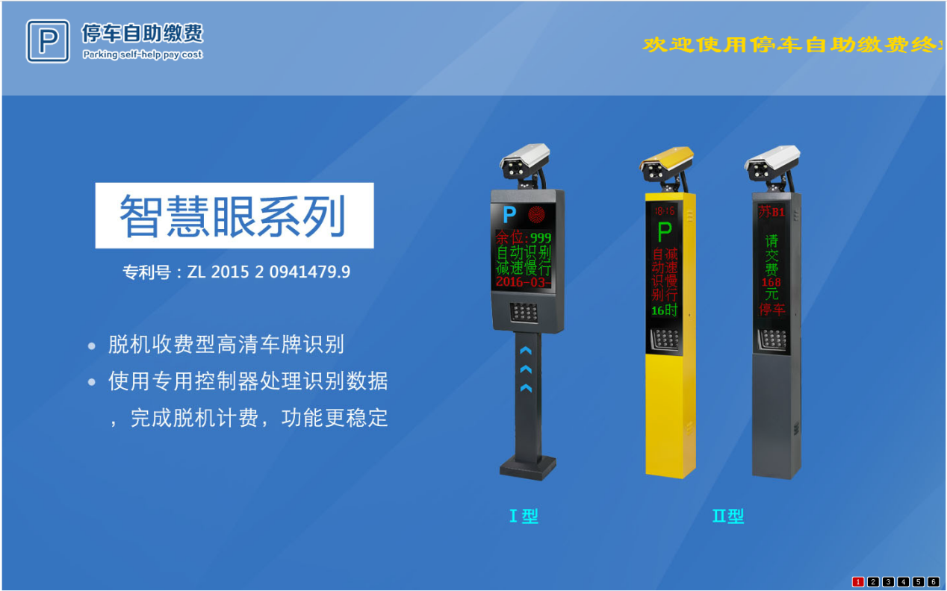

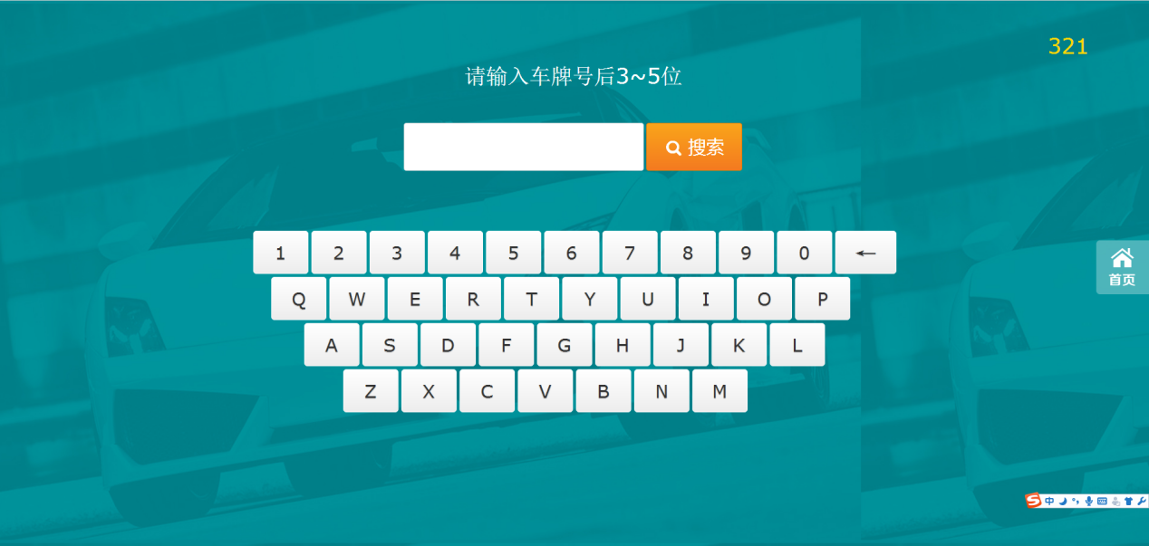

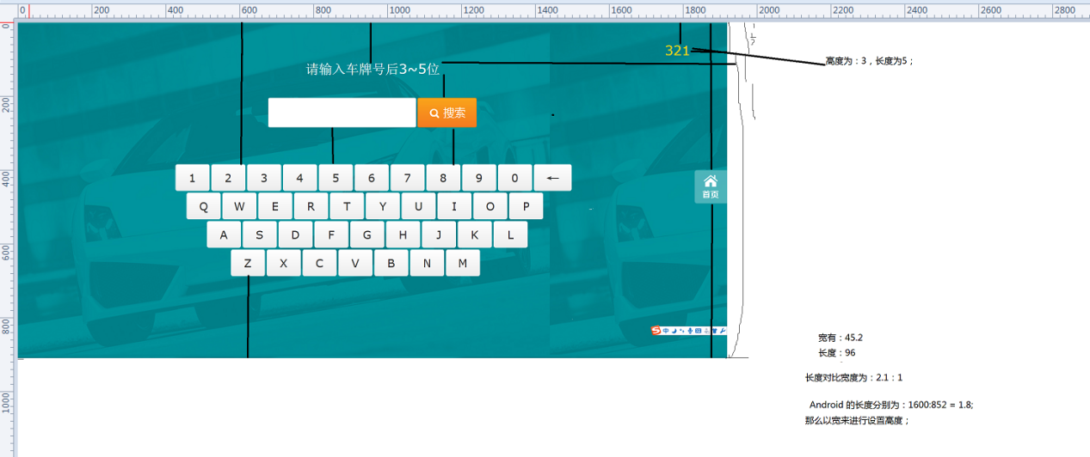

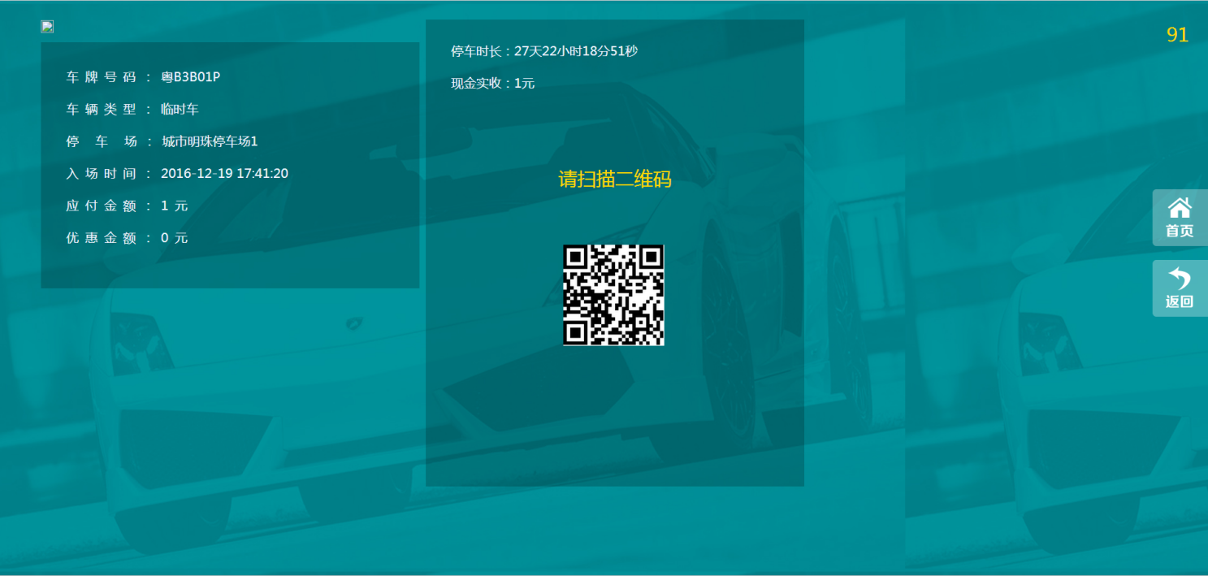

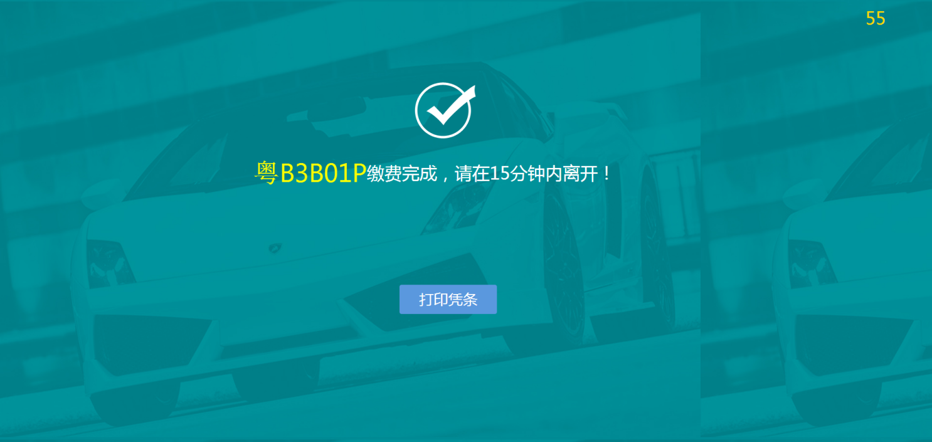

19, 通过车牌来获取停车信息；

<http://zjhwebpark.tunnel.qydev.com/TerApp/GetParkOrderList?appDevice_Sign=DB1222HS3&carNo=111>

获取车牌信息：

<http://zjhwebpark.tunnel.qydev.com/TerApp/OrderImg/e0b3ca87caf3a415bb3b3f52ca8aa795/20161116/20161116090713241-111111-0.jpg>

(照片暂时没有存在)

[http://zjhwebpark.tunnel.qydev.com/TerApp/GetParkOrderList/OrderImg/e0b3ca87caf3a415bb3b3f52ca8aa795/20161116/20161116090713241-111111-0.jpg](http://zjhwebpark.tunnel.qydev.com/TerApp/OrderImg/e0b3ca87caf3a415bb3b3f52ca8aa795/20161116/20161116090713241-111111-0.jpg)

18， 通过订单号来获取详细信息

<http://zjhwebpark.tunnel.qydev.com/TerApp/GetOrderDetails?ParkOrder_ID=95850>

<http://zjhwebpark.tunnel.qydev.com/TerApp/OrderImg/e0b3ca87caf3a415bb3b3f52ca8aa795/20161219/20161219151132885-B11111-0.jpg>

19，获取二维码

<http://zjhwebpark.tunnel.qydev.com/TerApp/GetValidateCode?PayType=203&ParkOrder_ID=95850>

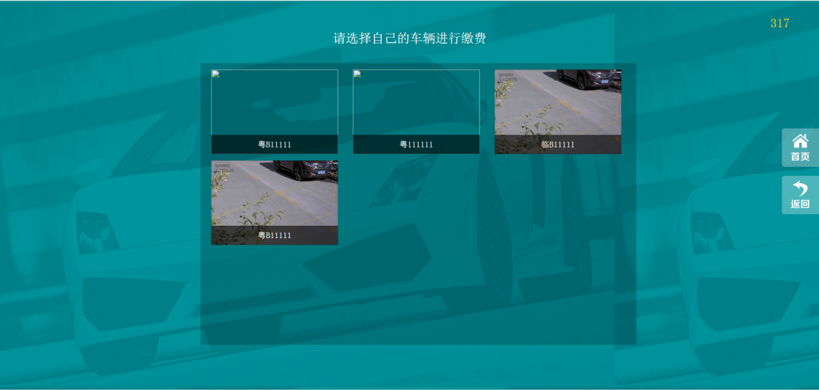

发现的新功能：

1，输入框的颜色为蓝色

2，输入框有光标；

3，右边有时间的移动；时间为322秒；

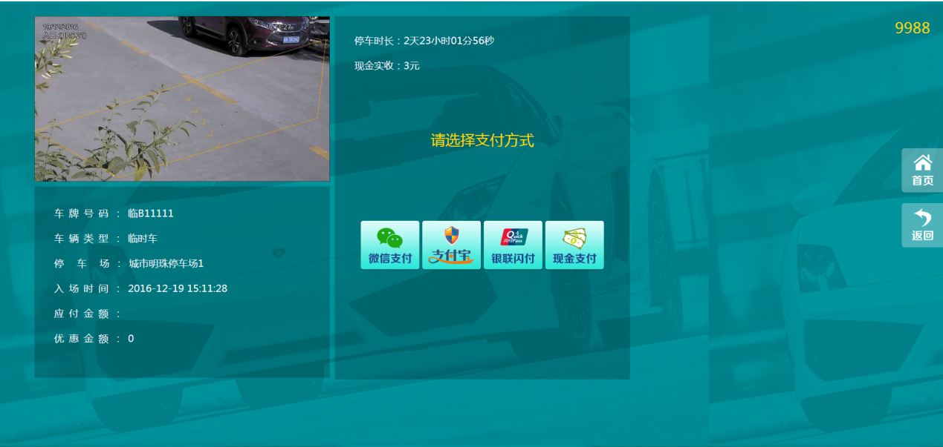

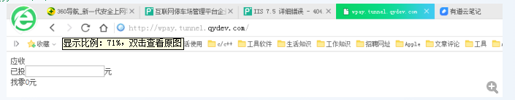

http://wpay.tunnel.qydev.com/

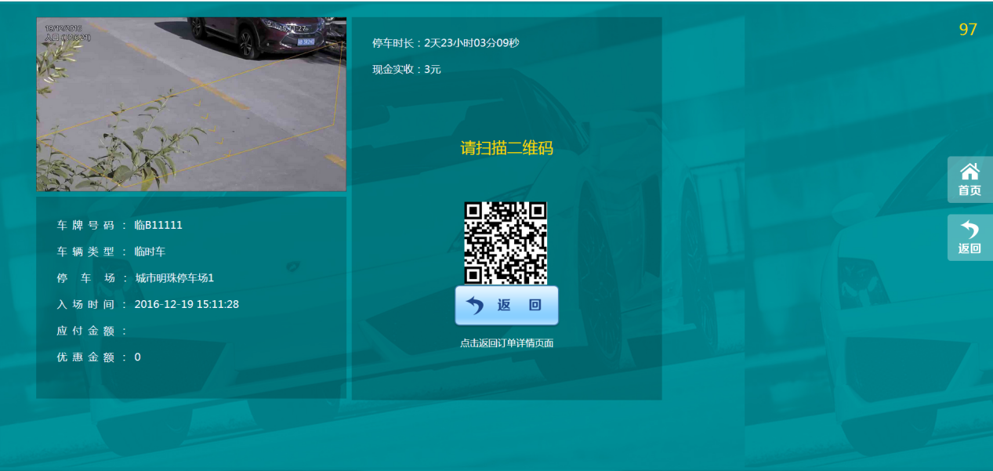

parkingetc.tunnel.qydev.com （2017 1_17）

[http://www.2cto.com\kf\201404\292989.html](http://www.2cto.com/kf/201404/292989.html)

<ImageView  
 android:id="@+id/imageView_config"  
 android:layout_width="wrap_content"  
 android:layout_height="wrap_content"  
 android:src="@drawable/abc_ab_solid_light_holo" />  
  
<ImageView  
 android:id="@+id/imageView_start"  
 android:layout_width="wrap_content"  
 android:layout_height="wrap_content"  
 android:src="@drawable/abc_ab_transparent_light_holo" />  
  
<ImageView  
 android:id="@+id/imageView_stop"  
 android:layout_width="wrap_content"  
 android:layout_height="wrap_content"  
 android:src="@drawable/abc_ic_clear_search_api_holo_light" />

java.lang.RuntimeException: Unable to instantiate application com.android.tools.fd.runtime.BootstrapApplication: java.lang.IllegalStateException: Unable to get package info for com.example.administrator.mycentralselfservice; is package not installed?

# 19，接收的新代码，如果用它自带的代码，则容易出现挂掉的情况；

现在把播放器给单独测试下：

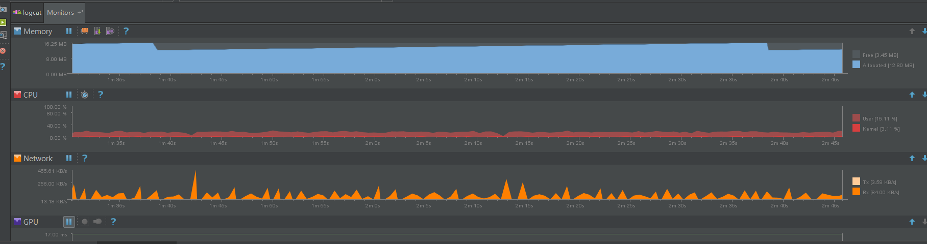

Cpu: 17%;

在内存的分配上，一段时间才会出现gc的过程；



刚开始播放两路视频时：

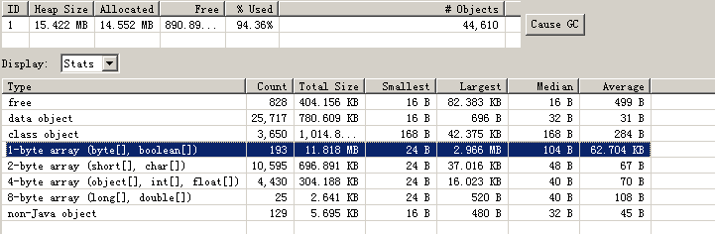

即heapSize = 15MB;

# 20, 摄像机的分辨率：720P

平板：内存(14~19MB) cpu(30% ~ 40%)

开发板：内存(14~19MB) cpu(20%) 开发板的配置>平板

出现的现象：一段时间后，内存还是往常一样，但是cpu变低了，编码和显示有问题；

AAPT err(Facade for 1175146510): ERROR: 9-patch image E:\Android_studio_workspaces001\zldhd\zldhd\src\main\res\drawable\leave_finish.9.png malformed.

AAPT err(Facade for 1175146510): Must have one-pixel frame that is either transparent or white.

AAPT err(Facade for 277017485): ERROR: 9-patch image E:\Android_studio_workspaces001\zldhd\zldhd\src\main\res\drawable\popwindow_bg.9.png malformed.

AAPT err(Facade for 277017485): No marked region found along edge.

AAPT err(Facade for 277017485): Found along top edge.

AAPT err(Facade for 998287572): libpng error: Not a PNG file

# 21，分布式停车场

## 1，登录页面

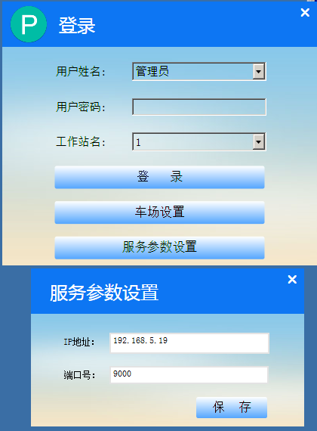

## 2，车场设置

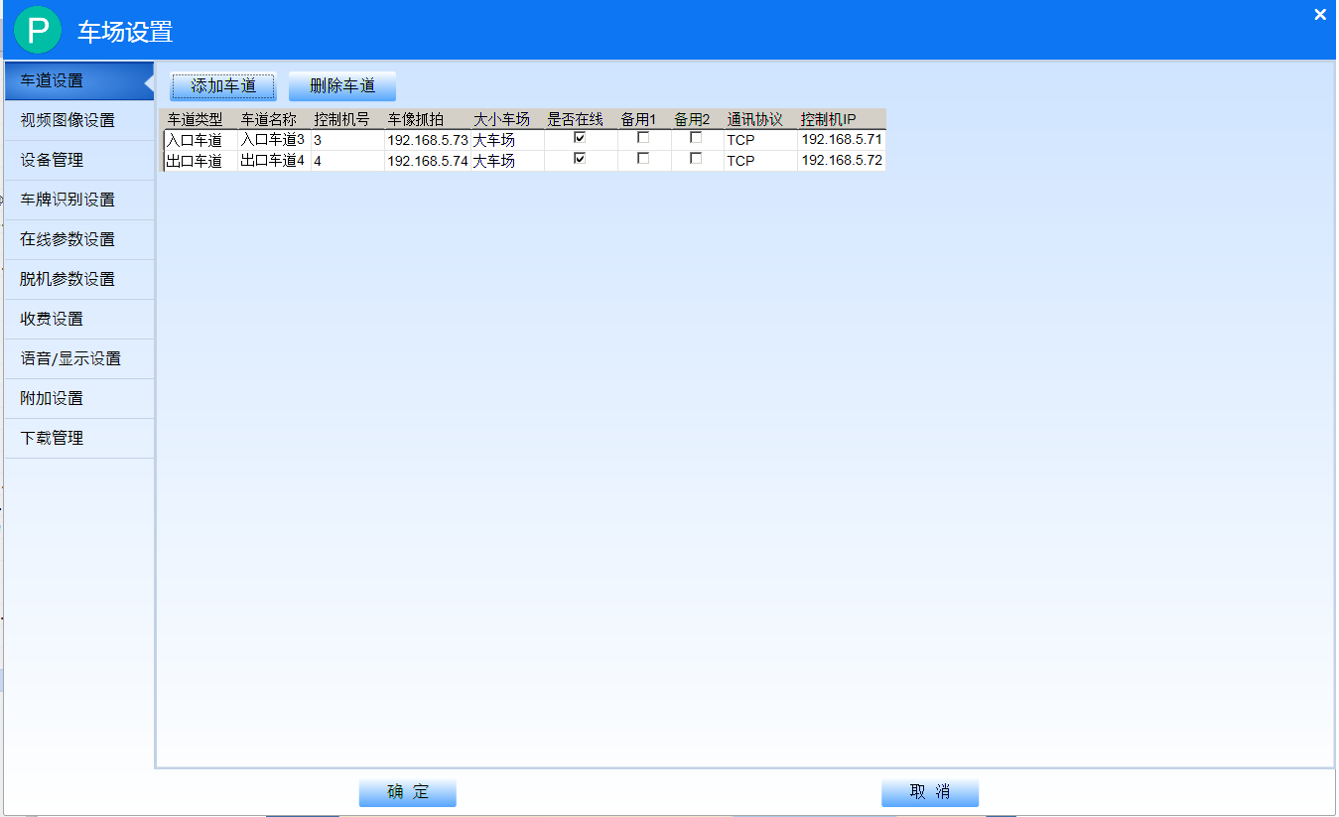

## 2.1，视频图像设置

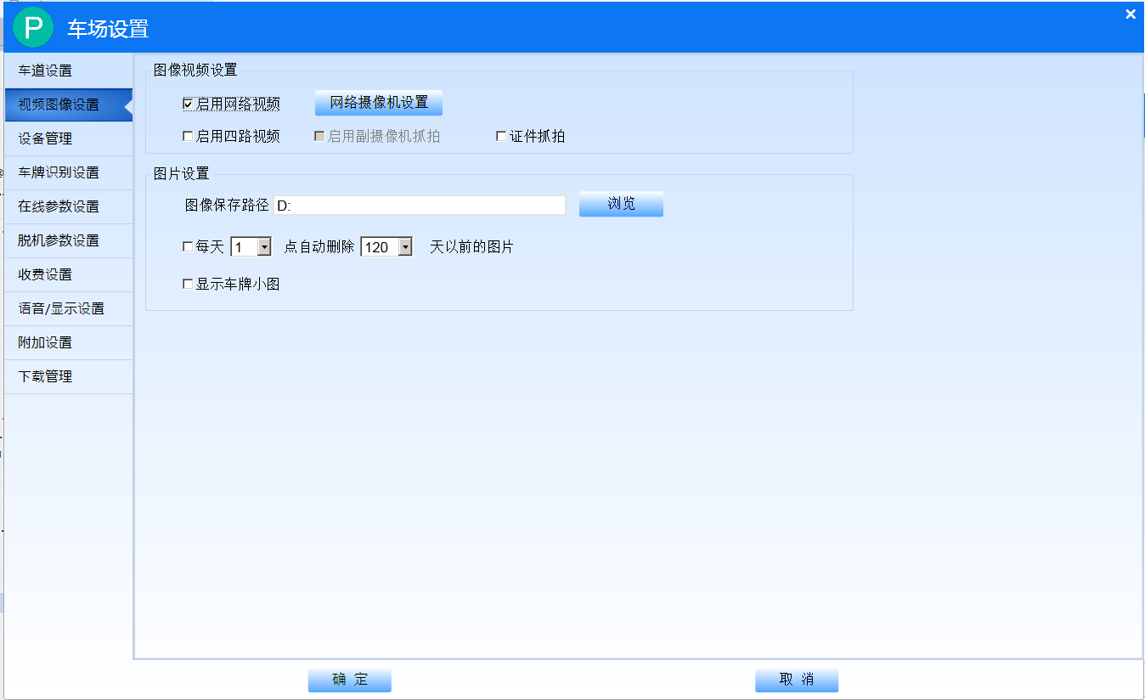

## 2.2，设备管理

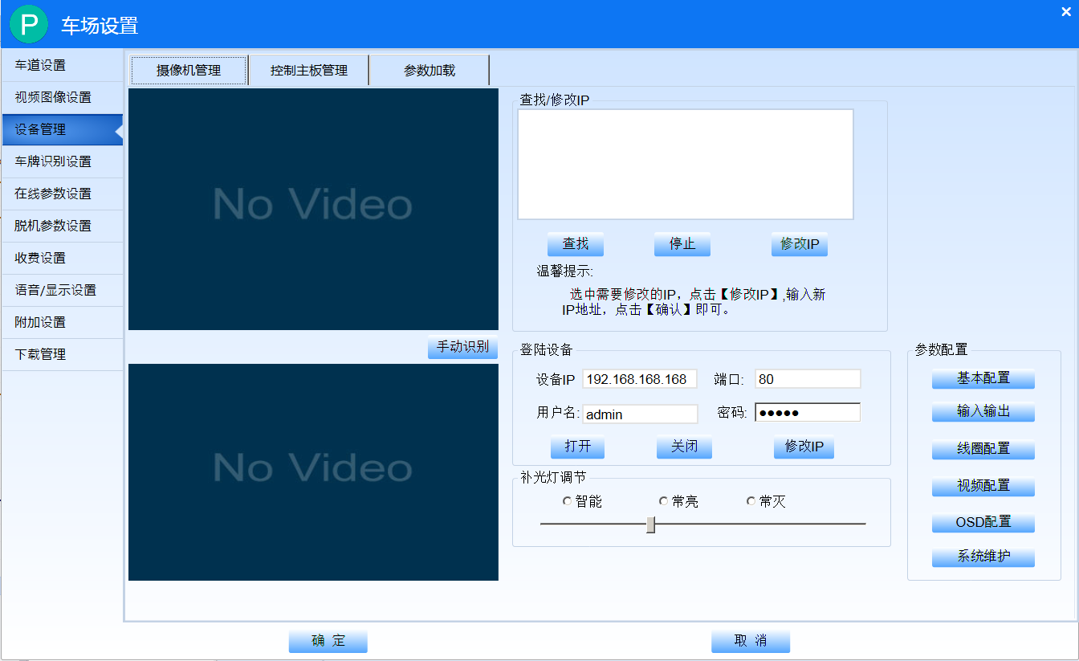

## 2.3，车牌识别

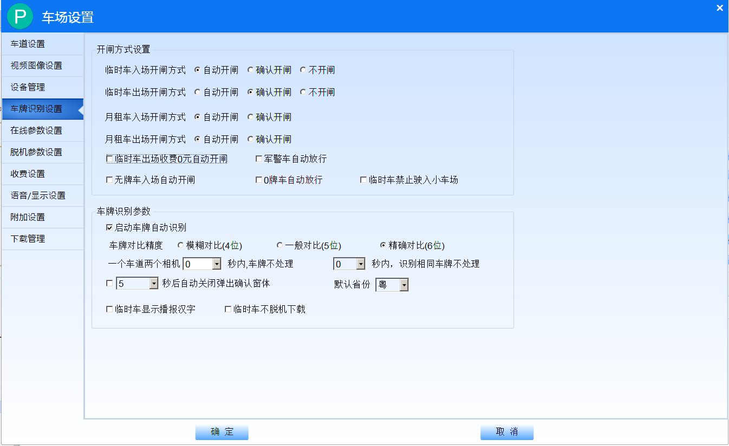

## 2.4，在线参数设置

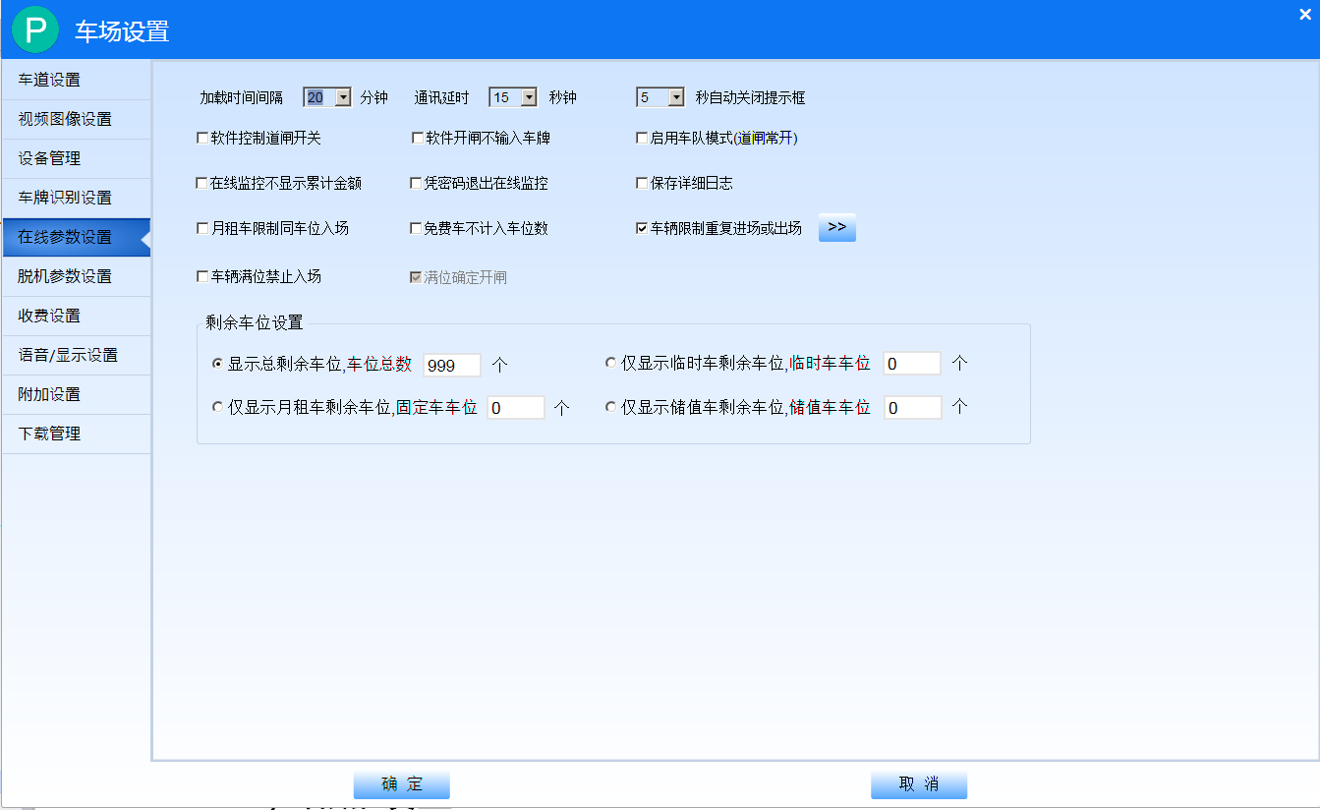

## 2.5，收费设置

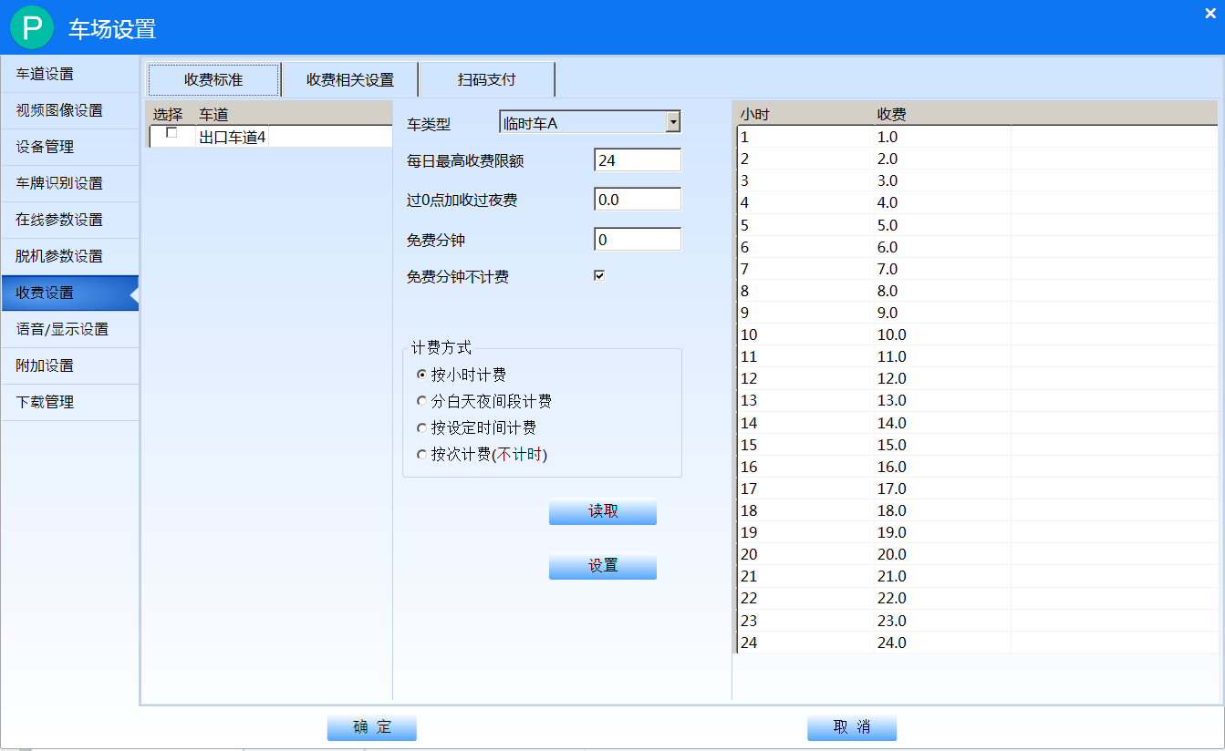

## 2.6，脱机参数设置

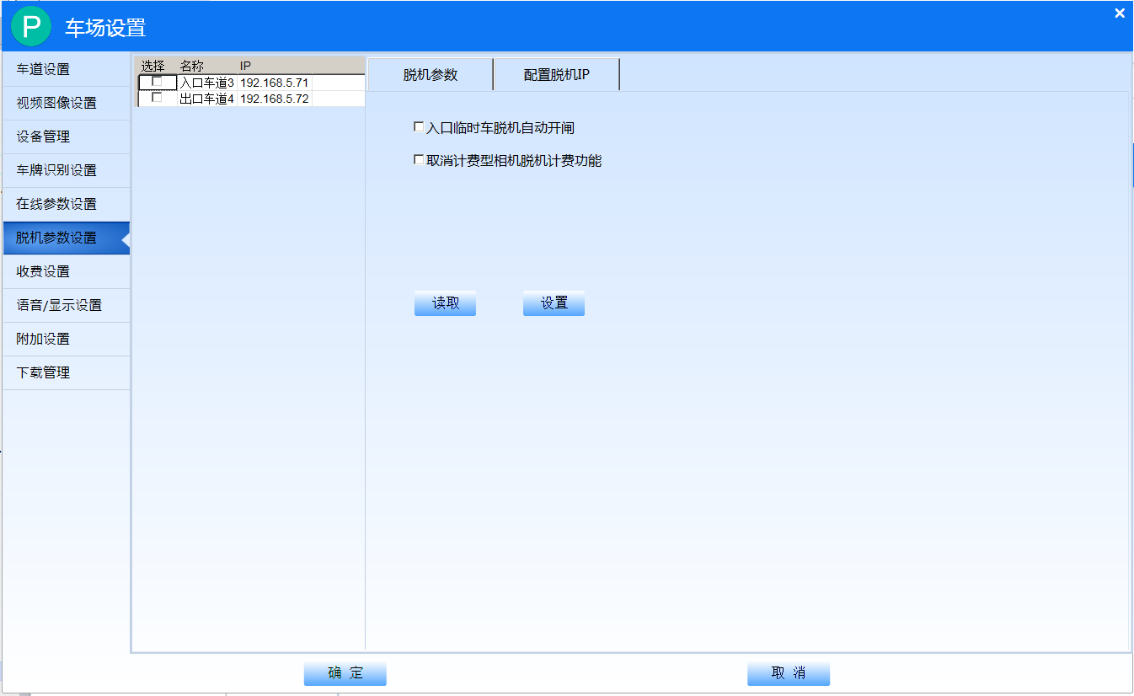

## 2.7，语音、显示设置

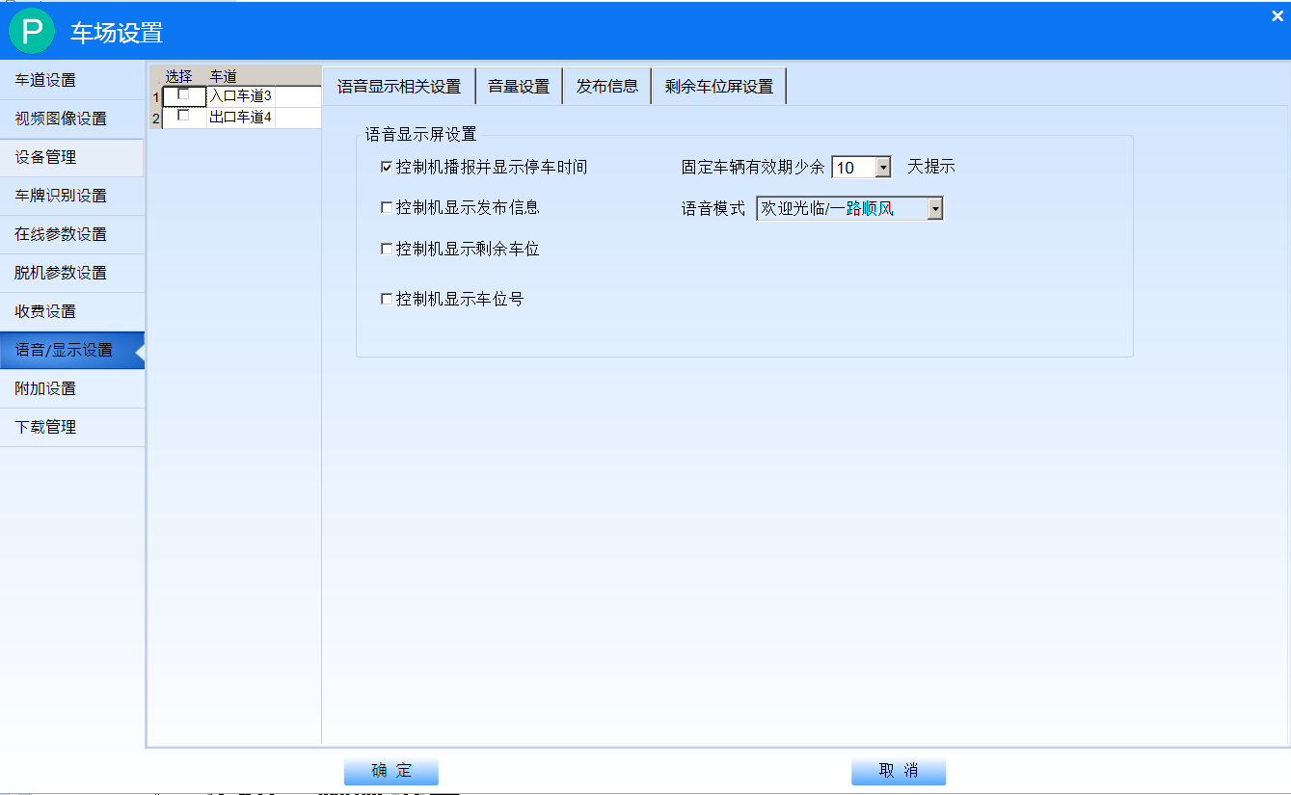

## 2.8，附加设置

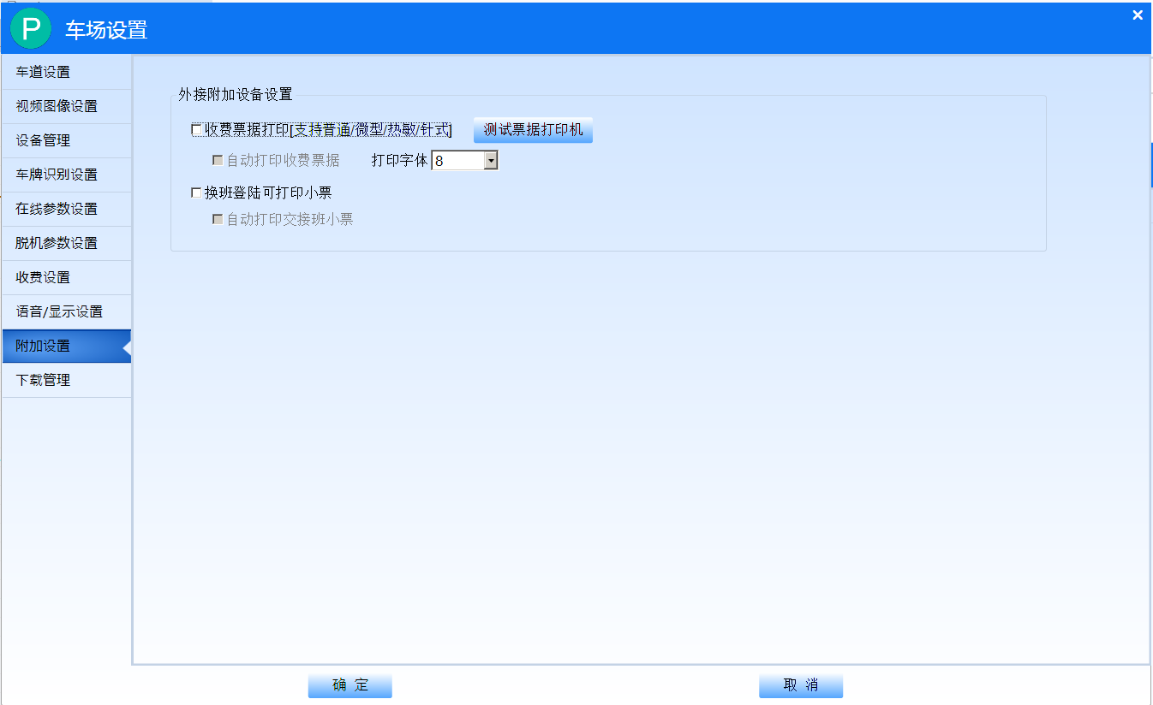

## 2.9，下载管理

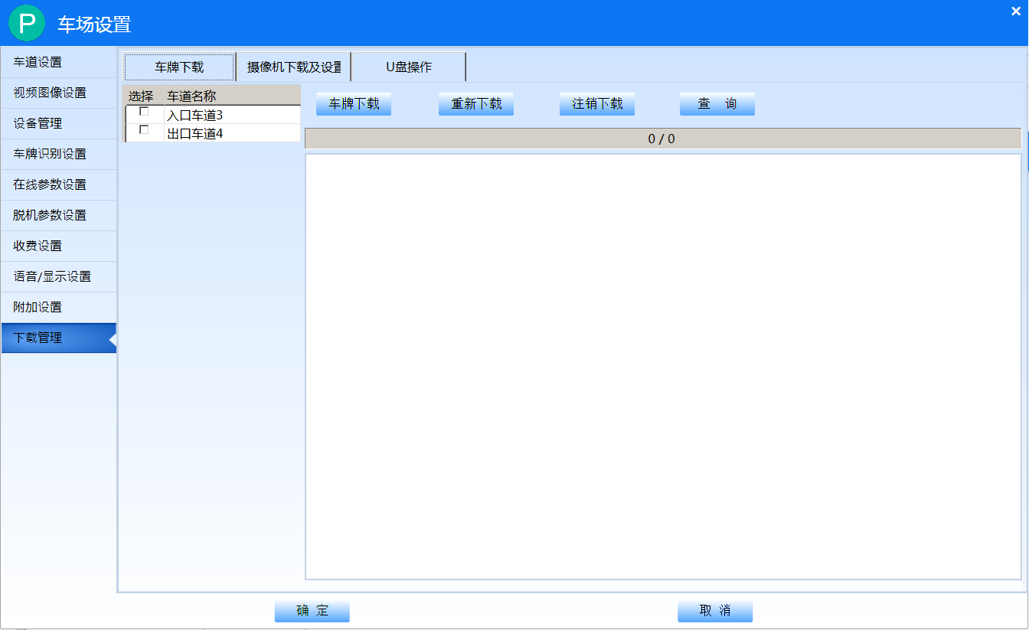

## 2.10，网络设置

# 3，登录页面-提取记录

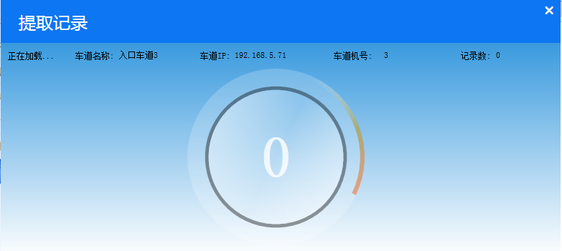

## 3.1，登录页面-在线监控

点击视频播放画面，可以全屏的显示；

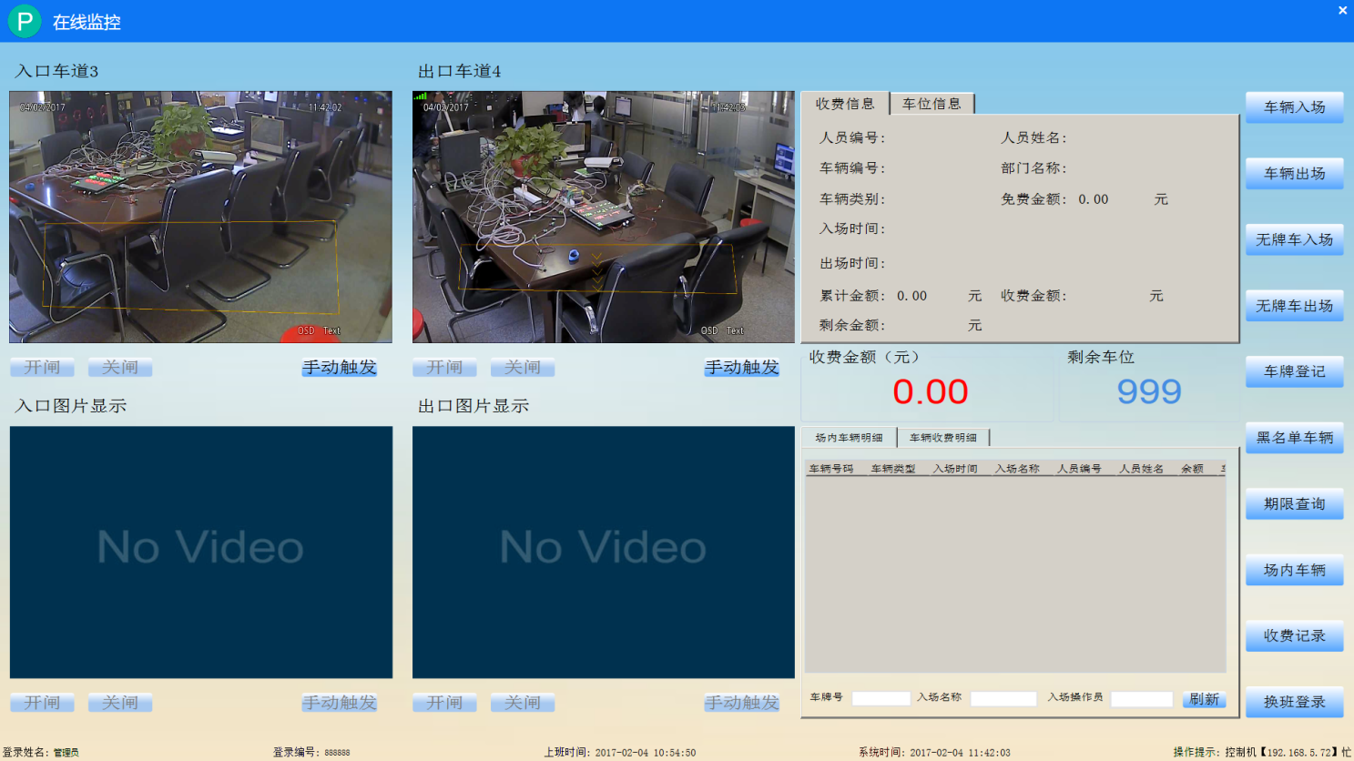

## 3.2，车辆入场

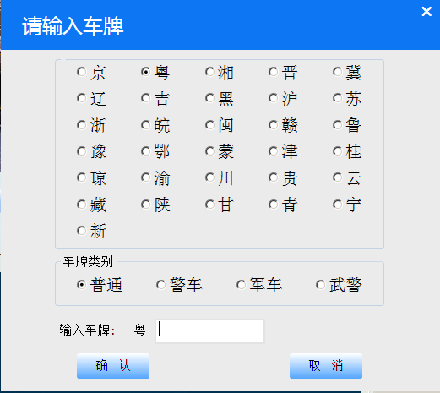

## 3.3，车辆出场-同车辆入场

## 3.4，无牌车入场

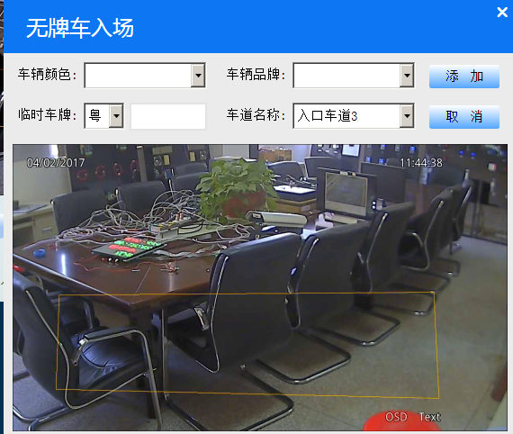

## 3.5，无牌车出场

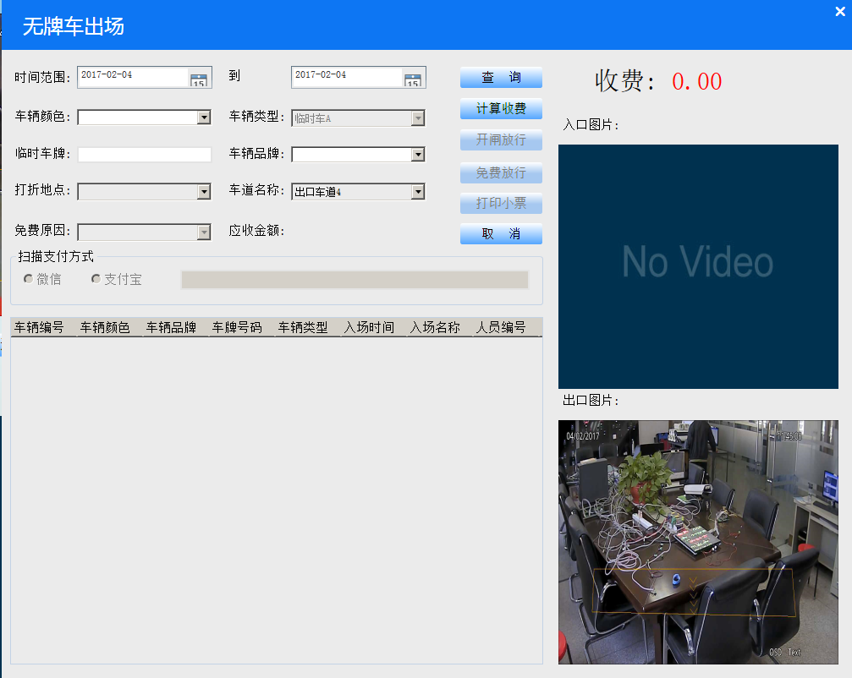

## 3.6，车牌登记

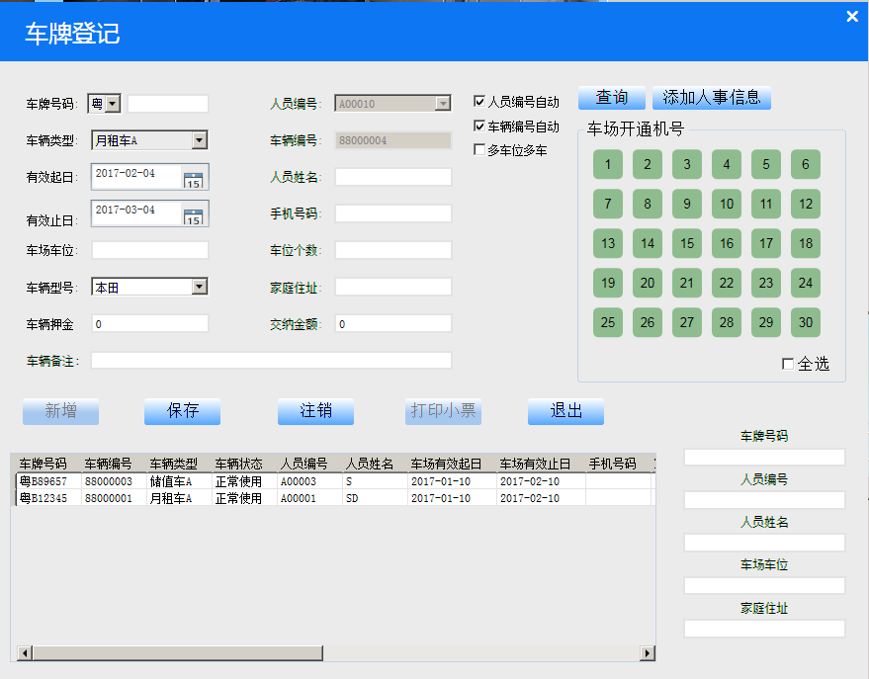

## 3.7，黑名单车辆

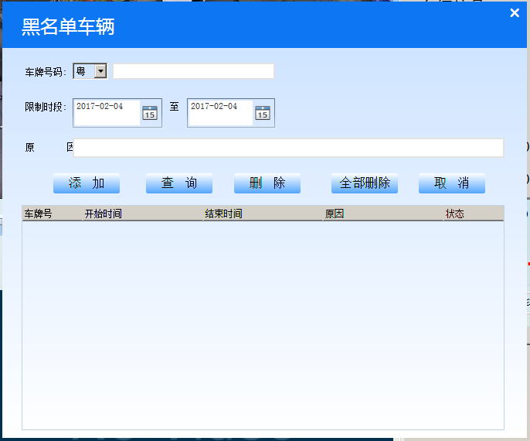

## 3.8，期限查询

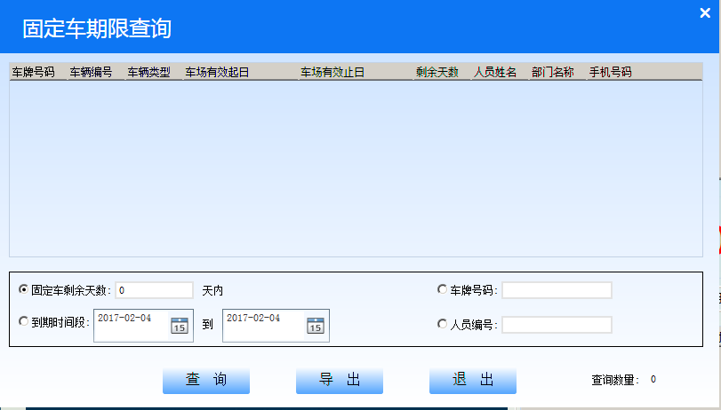

## 3.9，场内车辆查询

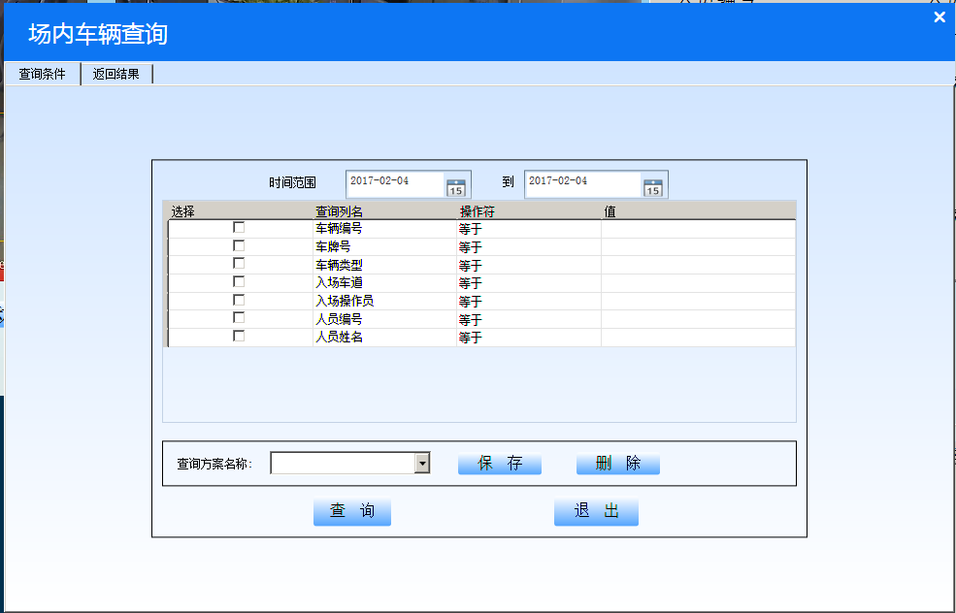

## 3.10，车辆收费查询

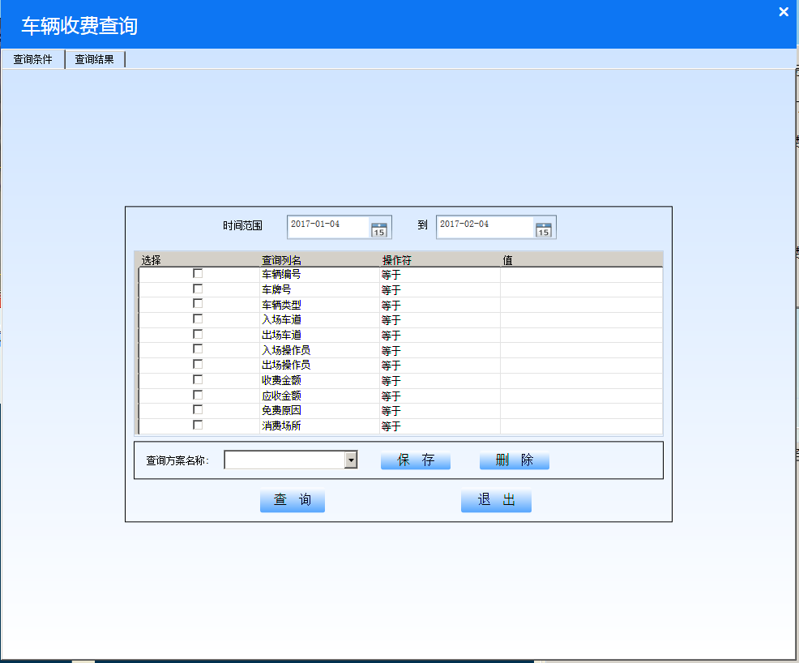

## 3.11，换班登录

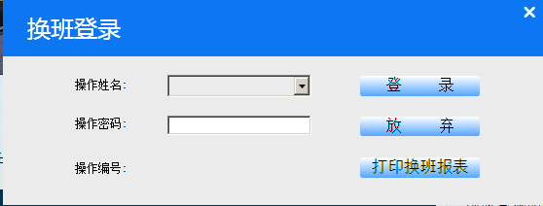

# Google guava导入出现错误：

For faster builds, increase the maximum heap size for the Gradle daemon to more than 2048 MB.

To do this set org.gradle.jvmargs=-Xmx2048M in the project gradle.properties.

Error:PARSE ERROR:

Error:unsupported class file version 52.0

Error:...while parsing com/google/common/annotations/Beta.class

Error:1 error; aborting

:myobserverdemo:transformClassesWithDexForDebug FAILED

Error:Execution failed for task ':myobserverdemo:transformClassesWithDexForDebug'.

> com.android.build.api.transform.TransformException: java.lang.RuntimeException: com.android.ide.common.process.ProcessException: java.util.concurrent.ExecutionException: com.android.ide.common.process.ProcessException: org.gradle.process.internal.ExecException: Process 'command 'D:\Program Files\Java\jdk1.8.0_66\bin\java.exe'' finished with non-zero exit value 1

猜想：apk运行的目标系统的版本号比较低，所以在下载低版本的guava可能工作；

分布式软件路径：

